Andrew Botsford
Andrew.botsford@inpex.co.jp
Andrew James Botsford (E5912101) B872 TMA02

TMA02
B872 CREATING AND SUSTAINING VALUE

Contents

Part 1 2
Transformation Processes 2
Key Performance Objectives 4
Layouts 4
Process Technologies 5
Nature of Demand 6
Supply Chain Interaction 6
Part 2 8
Part 3 10
Defining Value 10
Value Creation from Exploration 10
Business Intelligence 11
References 14

Part 1

Transformation Processes
The organisation provides hydrocarbons to customers. The inputs are the natural resource, and the tools and concepts used to find, extract, and deliver it. Processes undertaken include identification of resources, installation of facilities to extract the product, establishing delivering mechanisms to customers, and subsequently running these facilities (Figure 1). This report focuses on the hydrocarbon resource identification function of the business. Hydrocarbon resources are usually obtained by investing in data and its evaluation to drill wells and discover new resources (referred to as exploration). The transformation process in this department is a service that uses knowledge of geoscience, markets, and engineering to provide opportunities to increase the resource base of the organisation.
Potential order winners for our final products include cost, sustainability, and environmental impact. Order qualifiers are linked to safety performance and environmental factors which influence our license to operate. Our ability to meet these are strongly influenced by the location of the resource. Therefore, the resource identification stage of the organisations value chain is a critical component in meeting these criteria.
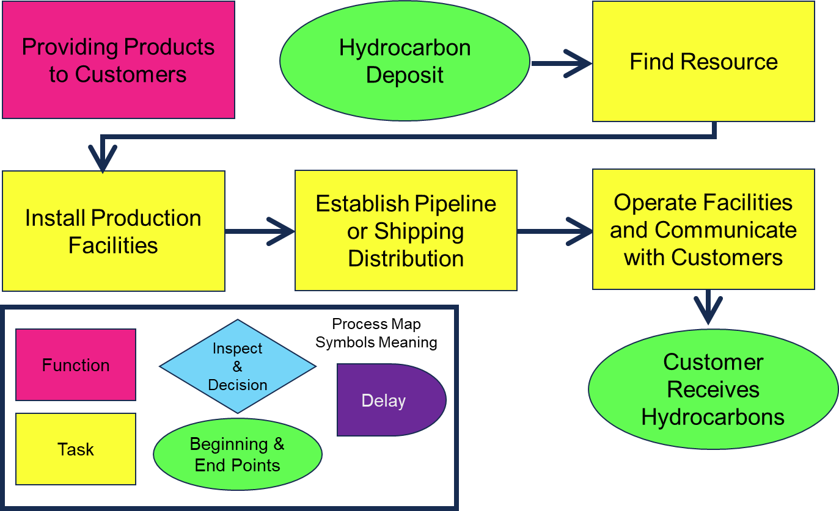
Figure 1: Process map of the general transformation workflow undertaken by the business and a guide to the meanings of each box used in the diagram (also relevant to Figure 2). Diagram designed using principles outlined in Demelio (2016).
A process map of the hydrocarbon resource identification function is shown in Figure 2. This shows how the strategic desire to add resources to the organisations inventory is facilitated by technical evaluations supported by further key strategic decisions at several stages through the process (shown in yellow rectangles).
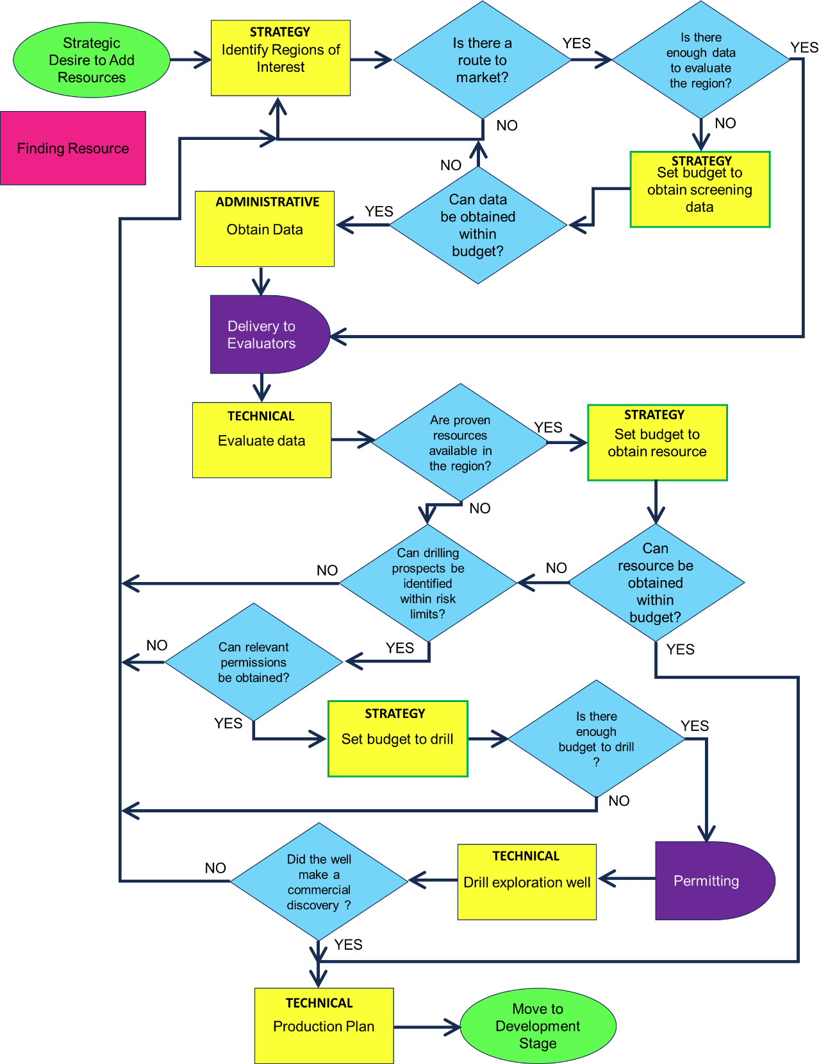
Figure 2: Process map of the function of adding resources to the organisation. Box meanings are outlined in Figure 1. The diagram labels strategic, administrative, and technical tasks with yes or no questions that need to be answered to achieve a new resource, either through an acquisition or by drilling an exploration well. Diagram designed using principles outlined in Demelio (2016).

Key Performance Objectives
An evaluation of the key performance objectives in the exploration function, as defined by the OU MBA module (Fenton-O’Creevy et al, 2023a), is outlined as follows in the sand cone model of Ferdows and De Meyer (1990) (Figure 3). The sand cone model was developed for manufacturing but is loosely applicable to this process. It emphasises quality and dependability as critical and foundational components of the process however flexibility, speed and cost are not necessarily less important. For example, data evaluations need to be delivered in timescales that meet project decision timelines, placing a greater emphasis on flexibility and speed than quality of the evaluation.
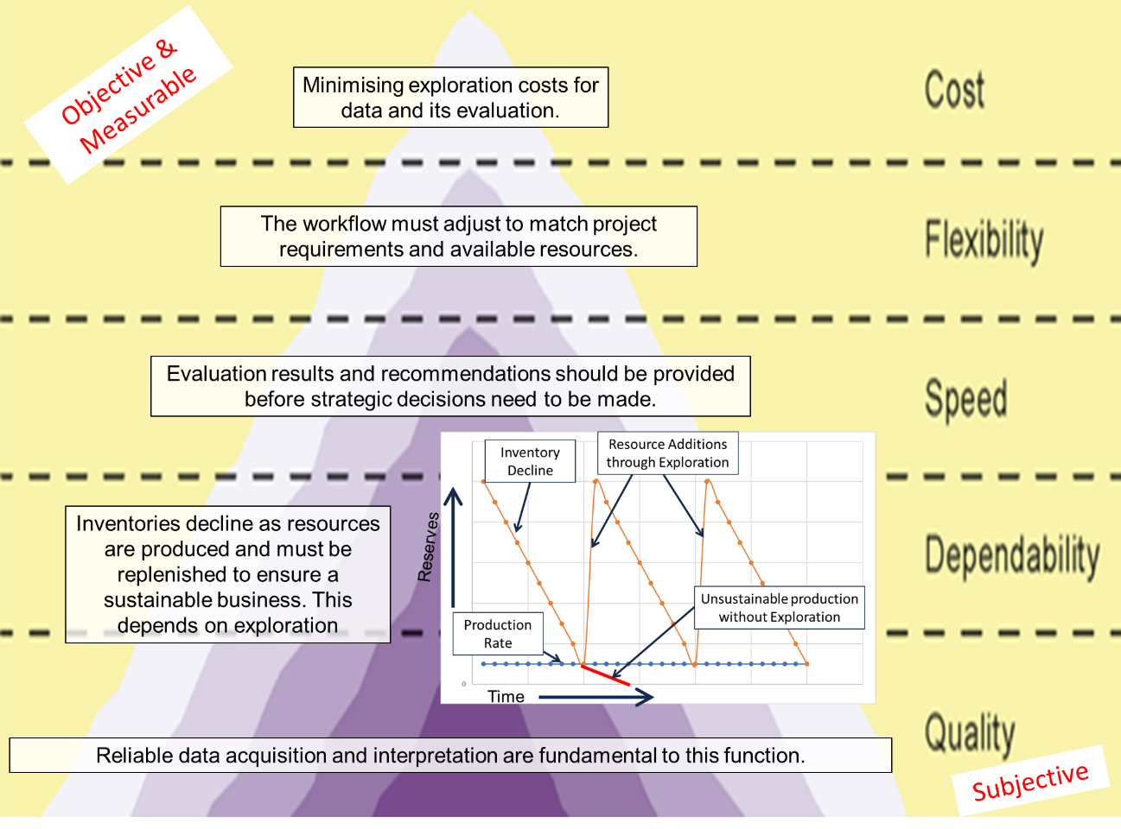
Figure 3: Application of performance objectives in hydrocarbon exploration applied to the Ferdows and De Meyer (1990) sand cone model.

Layouts
Figure 4 uses an approach from Fenton-O’Creevy et al (2023b) to classify the layouts of processes that are undertaken in the exploration function, based on tasks identified in the yellow boxes of Figure 2. End member functions operate in fixed position (well sites) or line layouts (data processing) from the point of view of information flow. Screening data (seismic) is highly standardised (in terms of data format) and of very high volume, well sites are very low in volume and rigs need to be highly customised and provide high variety of data outputs.
The office-based functions of budgeting, strategy and data evaluation can be separated using the volume and variety framework as follows. Budgets are performed often (high volume) and follow standard methods; they have a relatively cellular layout of passing through information. Strategic decisions utilise relatively standardised information but may require more customisation than budgets, a functional layout that is able to call on multiple disciplines is utilised. Exploration data evaluation requires a customised approach because it deals with nature and its unpredictability, a functional layout utilising a multidisciplinary team is required. Whilst all these functions are office based, the layout can be considered in terms of information flow and interactions between individuals.
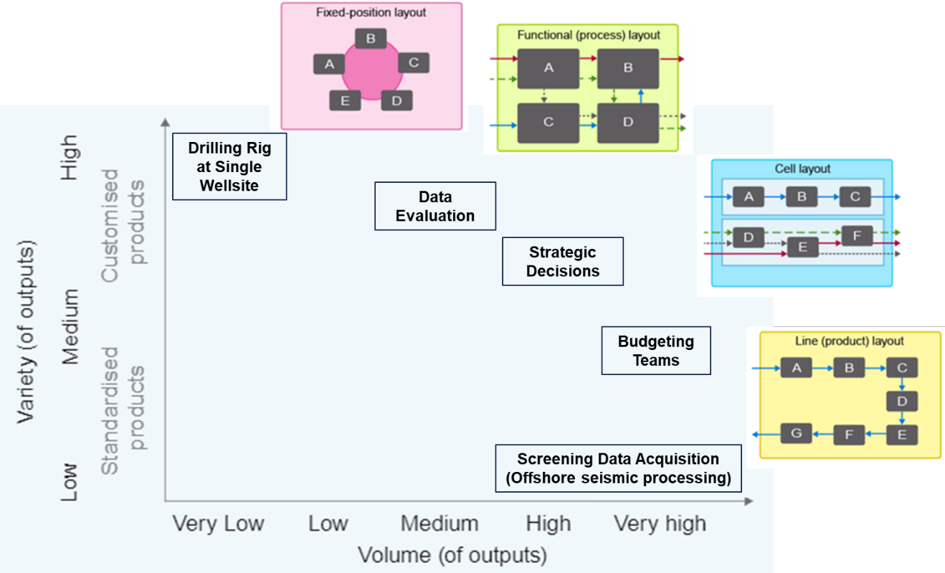
Figure 4: How aspects of exploration operations are organised in terms of layout, and their indicative volume and variety of outputs. Based on analysis introduced by Fenton-O’Creevy et al (2023b).

Process Technologies
Some examples of processing technologies employed in exploration are outlined in the following table which uses ideas from Fenton-O’Creevy et al (2023b):
Process Technologies | Direct | Indirect
Materials Processing to support data evaluation and inform strategy | Hydrocarbons- Core analysis for reservoir characterisation. | Hydrocarbons- Computational modelling of subsurface with seismic and well logs.
Customer Processing ensure needs are understood and met | Email communications. | Marketing such as logo and brand development.
Information Processing to maintain dependability and inform strategy | Monitoring of live well drilling or seismic acquisition. | Analysis of Business Intelligence obtained from external service providers.

Nature of Demand
The decision to add resources is linked to current inventories and predicted future demand. Ultimate product demand for hydrocarbons is often seasonal (eg more demand for gas in winter), longer term trends are linked to geopolitical and other factors. Business Intelligence (See Part 3) plays a key role in determining our appreciation of demand trends. This informs decisions on where and when we should invest in exploration, and how widely we should spread our resources. A diverse geographic spread will mitigate unforeseen production problems in one location but requires more resources and business intelligence. If new resources aren’t added at the same rate hydrocarbons are provided to customers, the value of the hydrocarbon part of our business will decrease over time. The nature of demand is a key challenge discussed further in Part 2.

Supply Chain Interaction
The supply chain is an essential component in exploration. External service providers are utilised to obtain data, evaluate data, support permitting, drill wells, and create production plans. The framework defined by Simatupang and Sridharan (2005) is used to evaluate areas of collaboration below:
Information Sharing | Communication is key to enable information sharing, but sometimes key strategic information might need to be guarded for confidentiality reasons linked to our business intelligence.
Decision Synchronisation | Project timelines are established with key milestones.
Process Integration | Process bottlenecks are a risk if decision making takes too long in any component of the supply chain (eg permitting for wells). This can be mitigated by good understanding of how decisions are made and by adding contingency to project timelines.
Collaborative Performance Measurement | KPIs for our suppliers are heavily linked to timely delivery, but also include data quality metrics (by comparison with other data).
Incentive Alignment | Contracts are usually shaped to ensure payment after satisfactory delivery of a component. In some cases, bonus payments are made at various stages of the exploration workflow.

Part 2
Market variability can strongly influence strategic desire to add new resources. In times of high demand there is more motivation to increase resources, but also more competition for these resources. When there is lower demand for hydrocarbons the exploration budget is often reduced so our ability to obtain data and to recruit and retain staff to evaluate data declines. This has negative impact on the foundational performance objectives of quality and flexibility (Figure 3) and often occurs when there may be less external competition for access to exploration opportunities so will result in missed opportunities to add resource at lower cost.
The “Lean management” approach outlined by Womack et al (1991) to reduce resource wastage would impose severe restrictions on the exploration department as it could lead to excessive cuts in staff, data acquisition, and software during periods of low demand that could not be built back up again when the situation changes. Some lean approaches could be useful to trim underutilised resource, but I do not think it is a good guiding principle in the exploration department due to the variation outlined above.
As an alternative approach it is proposed that the exploration function applies the theory of constraints (Goldratt and Cox, 1984) to ensure sufficient resources (eg staff, data and software tools) are available to meet demand and take advantages of opportunities when there is less competition. This approach will identify stumbling blocks on our path to adding new reserves so we can best direct new capital investments and help ensure that our chances of making successful discoveries when they are needed is maximised.
The first step is to identify potential constraints. Figure 2 shows several questions that need to be answered in the exploration workflow. To answer these questions, we need sufficient information including knowledge of markets, data availability, data analysis, regulations, and budgets. For each of these questions we need to ask whether we have sufficient information to make the decision and if not whether there is an ongoing process to gain such knowledge.
For the most advanced question in the process “Did the well make a commercial discovery?” we need to know what a commercial discovery would be (market knowledge) and have sufficient staff resources to understand the data obtained by the well (data analysis knowledge). If we cannot answer the question effectively it is clear, we have found a constraint that requires attention. It might be necessary to understand whether the constraint is caused by lack of suitable data or our analytical capability. A challenge with this approach is that it is hard to know how much analysis is enough and excess could occur. At some point a decision based on evaluation of available information will need to be made however much analysis has been undertaken.
The preceding question in the well drilling case of Figure 2 asks, “Is there enough budget to drill?” which requires knowledge of budgets. A budget constraint at this stage would render any preceding work a waste so it makes sense to start looking for constraints moving back from the end of the process map and to consider the entire process from the start. This also emphasises the need to maintain consistent budgets to minimise constraints, sometimes boldly ignoring external market conditions.
After constraints have been identified the relevant improvements should be made, often by recruiting or training staff or investing in new data. It is critical that overall strategy supports this approach by providing the necessary financial support and a long-term market perspective should be maintained to avoid short term cost cutting.
Overall, it is recommended that the exploration function can respond to the challenge of variable resource demand by a maintaining constant focus on our ability to answer the questions in the process map (Figure 2). This will make sure we are suitably equipped to respond to demand surges but also able to exploit market opportunities during periods of reduced competition. The alternative lean approach might minimise costs but will not be nimble enough to support any growth.

Part 3

Defining Value
Our interactions with suppliers and external stakeholders are aligned with producer surplus theories of Windsor (2017) in that services are employed to support the function of finding new resources as and when required (for example using a contractor to acquire seismic data for us). These services support resource addition and subsequently value creation for shareholders, and although value may be created for suppliers it is usually considered supplementary to the process.
An alternative view would recognise that the separation of producer surplus and multiple stakeholder approaches of Windsor (2017) and assigning only one to an organisation is problematic as it wouldn’t recognise the diverse ways different processes are managed and that the approaches of individuals within the business might not be the same. An example of where multiple stakeholders might be considered beyond just shareholders is when we take on work experience students. In this case there is no likelihood of the student working for us and it costs us time, the only motivation is a philanthropic sense of educating the child and creating value beyond that of the organisation by supporting education unrelated to our business.
The multiple stakeholder view of value creation in exploration recognises the value added to contractors, students, nations, citizens, and more as part of the process rather than an accessory to our organisation’s needs. It is harder to take this approach when considering value creation of a single organisation as the far-reaching considerations of value cannot be easily defined. This analysis of one organisation is mainly within the producer surplus theory framework.

Value Creation from Exploration
The operational function of resource addition contributes to creating value by replenishing the stock (oil and gas) provided to customers by allowing primary activities to continue. The function can be placed in the procurement category of the value chain model of Porter (2001) (Figure 5). With this application of the model, the primary activity of operation concerns extraction of oil and gas for delivery and takes resource existence for granted. Operations can also be defined beyond the narrow scope used in this model. The model shown in Figure 5 also helps illustrate where resource addition fits within the value creation process, although support activities such as human resource management and administrative support are also required by the procurement function which might not be clear from the illustration.
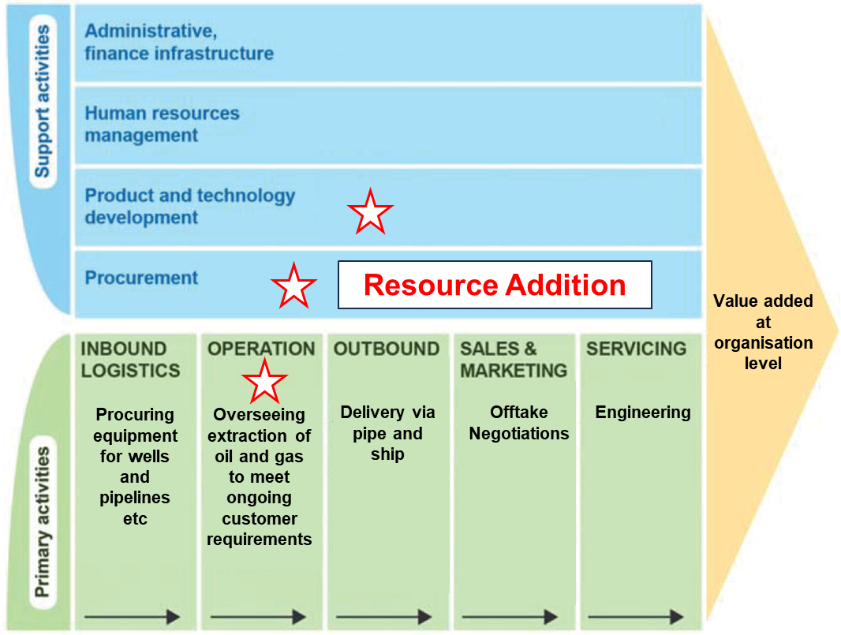
Figure 5: Application of the oil and gas production business to the value chain model of Porter (2001). Resource addition (or exploration) aligns with the support activity of procurement, although overlaps with product and technology development and the hydrocarbon production unit occur and are indicated by a star.

Business Intelligence
Business Intelligence (BI) plays a crucial role in informing our strategy and in accessing new resources. Some applications are outlined below:
BI Application | How is it utilised?
Market Analysis | Uses predictive and prescriptive analysis to understand likely future demand. Applied to inform strategic investment decisions.
Competitor Intelligence | Describe where they are exploring and predict whether they will be directly competing for resources. Identify and describe any new technologies they may be using.
Prospect Identification | To make recommendations on where to drill (prescriptive analysis).
Process Improvement | To understand available technologies that can help improve our exploration well success rates.

BI comes from a wide range of sources such as news service providers, partner and supply chain meetings, our own data acquisitions, local governments, academic and research institutions, and other wider stakeholders. Understanding what the most useful information will be in terms of increasing the likelihood of success in exploration or adding a valuable resource is gained through training, experience, using the data, and applying it in a relevant context.
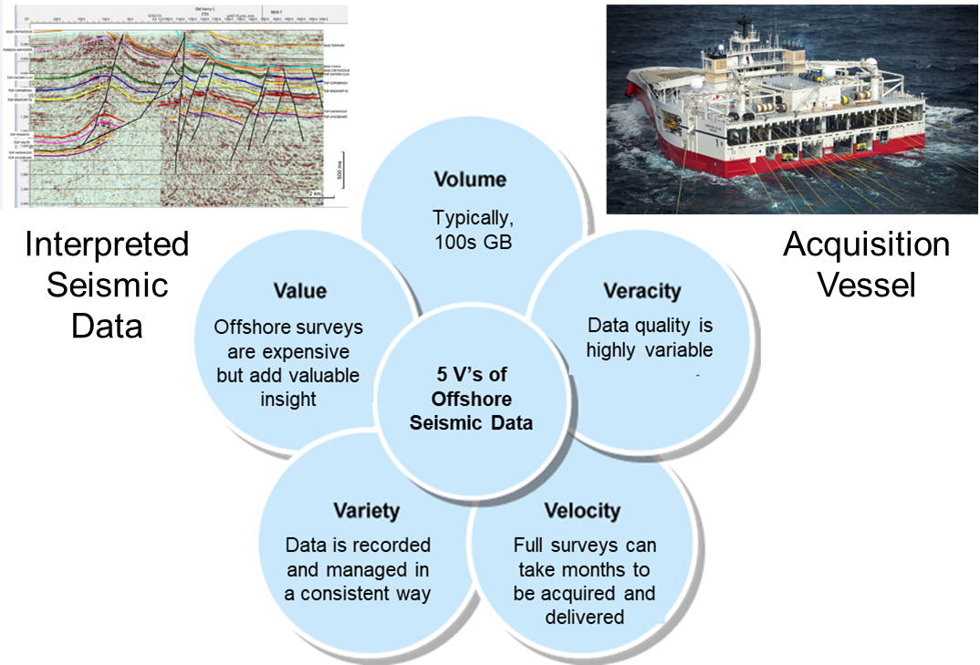
Figure 6: Application of the 5Vs of big data (Hariri et al, 2019) to offshore seismic, a key tool in prospect identification. Images from UKOGL (2022) and Offshore Energy (2021).
A key example of a technology used for identifying potential new resources is seismic data (Figure 6). This is used for modelling the subsurface and identifying hydrocarbon prospects. These data undergo intensive processing from when they are acquired to when the results are presented to strategic decision makers. Decision makers use the data and recommendations with other BI from market analysis and competitor intelligence to make decisions that align with our objective of increasing organisational value (Figure 5).
As our resource base is replenished through product sales, a failure to add new resources could lead to value destruction. We therefore must keep our resource base growing for business sustainability. The operational function of finding resources for the organisation provides the raw material input which is processed and provided to customers. Obtaining new resources in a competitive way provides increased access to markets and improved value to the organisation through financial revenue and to customers through provision of energy. The operation of finding oil also creates value for a wider array of stakeholders through our investments in services, local economies, and technology. We also add non-financial value by increasing humanities knowledge of geoscience and engineering.

References
Damelio, R. (2016) The basics of process mapping. 2nd edn. New York: Productivity Press.
Fenton-O'Creevy, M., Amor,.K., Claes, B., Knell, L., Tahera, K., Baralou, E., Bloom, P., Ponte, B., Samiotis, K., & Unnamed other (2023a) 'B872 Session 2 Operations value: performance objectives and strategies'. B872: Creating and Sustaining Value. The Open University. Unpublished.
Fenton-O'Creevy, M., Amor,.K., Claes, B., Knell, L., Tahera, K., Baralou, E., Bloom, P., Ponte, B., Samiotis, K., & Unnamed other (2023b) 'B872 Session 3 Operations design'. B872: Creating and Sustaining Value. The Open University. Unpublished.
Ferdows, K. and De Meyer, A. (1990) ‘Lasting improvements in manufacturing performance: in search of a new theory’, Journal of Operations Management, 9(2), pp. 168–184. doi: 10.1016/0272-6963(90)90094-T.
Goldratt, E.M. and Cox, J. (1984) The goal: a process of ongoing improvement. Croton-on-Hudson, New York: North River Press.
Hariri, R. H., Fredericks, E. M. and Bowers, K. M. (2019) ‘Uncertainty in big data analytics: survey, opportunities, and challenges’, Journal of Big Data, 6(1), pp. 1–16.
Offshore Energy (2021) ‘Global seismic vessel fleet at pre-Covid level as energy transition jobs ramp up’. Available: https://www.offshore-energy.biz/global-seismic-vessel-fleet-at-pre-covid-level-as-energy-transition-jobs-ramp-up/ (Accessed: 2nd February 2024)
Porter, M.E. (2001) ‘The value chain and competitive advantage’, in Barnes, D. (ed.), Understanding business processes. London: Routledge, pp.50–66
Sasser, W.E. (1976) ‘Match supply and demand in service industries’, Harvard Business Review, 54(6), pp. 133–140.
Simatupang, T.M. and Sridharan, R. (2005) ‘An integrative framework for supply chain collaboration’, International Journal of Logistics Management, 16(2), pp. 257–274.
UKOGL (2022) ‘Poole Bay 2D, 3D Seismic and Well Data now available from UKOGL’. Available: https://ukogl.org.uk/poole-bay-2d-3d-seismic-and-well-data-now-available-from-ukogl/ (Accessed: 2nd February 2024)
Windsor, D. (2017) ‘Value creation theory: Literature review and theory assessment’, in Wasileski, D. M. & Weber, J. (eds.), Stakeholder management. Bingley, UK: Emerald
Publishing Ltd, pp. 75–100
Womack, J.P., Jones, D.T. and Roos, D. (1991) The machine that changed the world: the story of lean production. New York: Harper Perennial.

